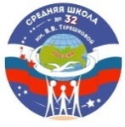 | Муниципальное общеобразовательное учреждение «Средняя школа № 32  имени В.В. Терешковой»

«From the school path to the stars»

Memorable places associated with V. V. Tereshkova
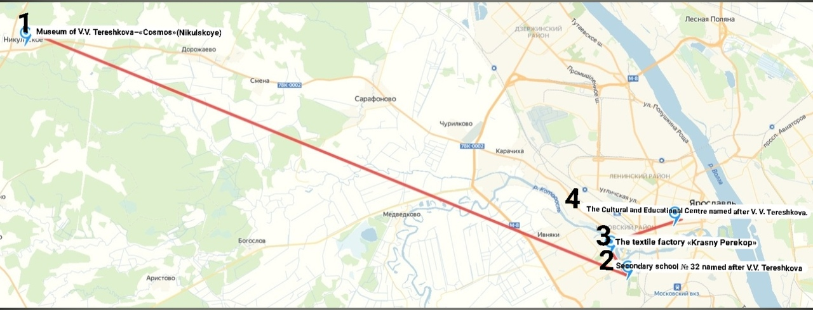
The Cultural and Educational Centre named after V. V. Tereshkova
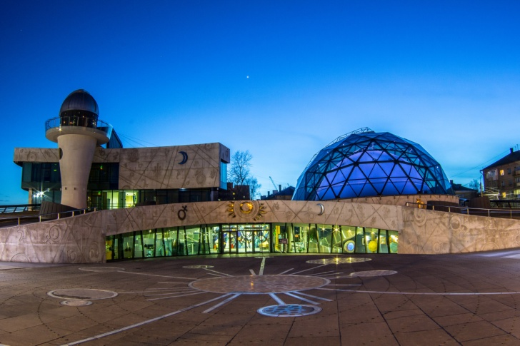The cultural and educational center named after V.V. Tereshkova consists of four parts: a modern planetarium with three-dimensional computer visualization; an observatory; an exhibition hall "History of Cosmonautics"; a cognitive and entertainment complex "Trans-force".
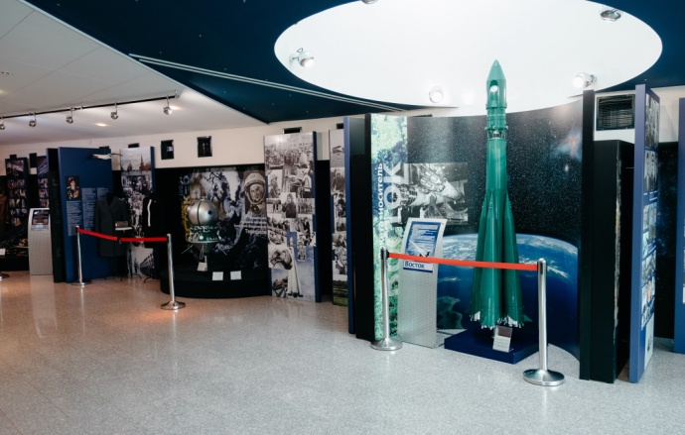
- +7 4852 72-82-00, +7 4852 72-91-55
- 3 Tchaikovsky Street, Yaroslavl', Russia

Museum of V. V. Tereshkova – «Cosmos» ( Nikulskoye)
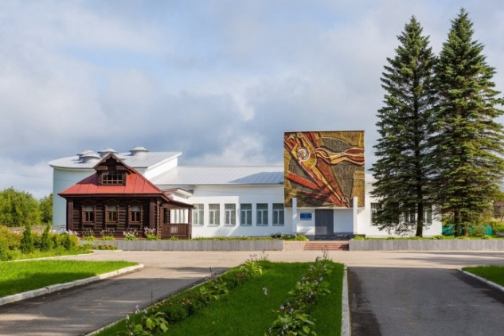
The museum is located in a small village (27 km from Yaroslavl). It was built in 1975.
The museum consists of:
- a main exhibition hall;
- a foyer;
- a copy of the house.
Work schedule:Wednesday-Sunday: 9:30 - 4:30
Monday-Tuesday: day off
Every first Wednesday of the month is a sanitary day, the exposition does not work.
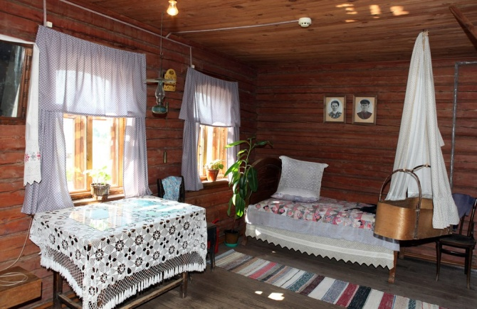
- : +7 910 973-77-95
- : Yaroslavl region, Tutaevsky district (Nikulskoe),42, Central Street.
Secondary school № 32 named after V.V. Tereshkova
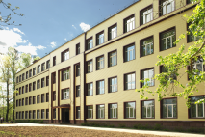
It was opened on September 1st, 1935. Valentina entered to the secondary school No. 32 in 1945.
The museum of school №32
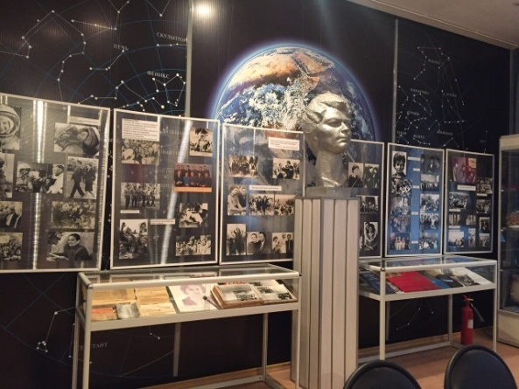
The room-museum of the first woman-cosmonaut was created in 1973 in the classroom where Valentina Vladimirovna studied.
Work schedule: Monday- Friday (by appointment)
Free admission
: 8-4852-45-03-91
- 1b, Lesnaya Street, Yaroslavl', Russia

The textile factory «Krasny Perekop»
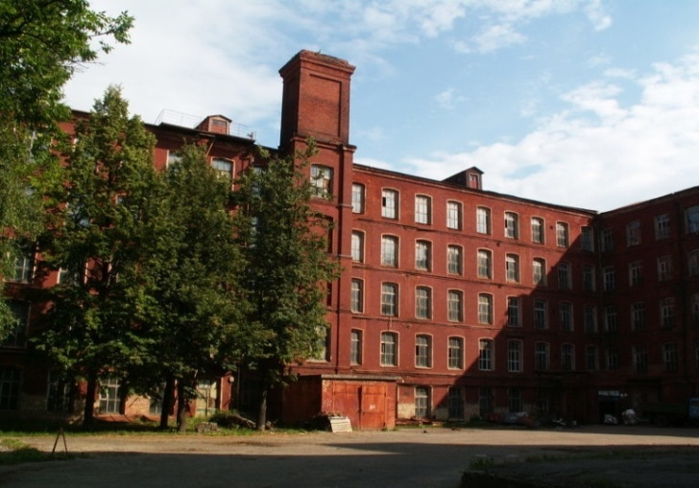The factory was founded in 1722. The first female astronaut worked here (1955-1961).
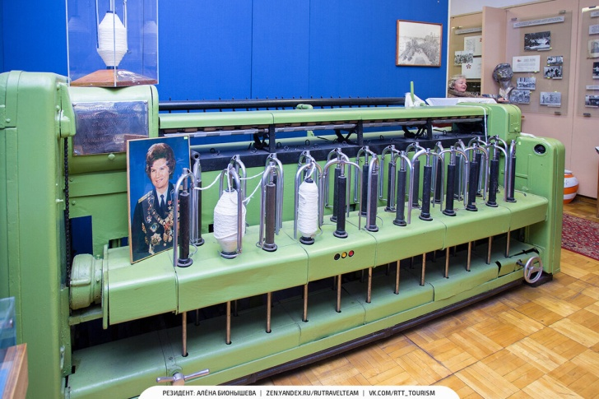
There is a special stand with information and lots of photos dedicated to Tereshkova in the factory. Nowadays people can organize an excursion to the factory.
- :+7 4852 21-45-74
63, Stachek Street Yaroslavl', Russia

